

EVENT RECOGNITION

A Project Report submitted in partial fulfilment of the requirements for the award of the degree of
Bachelor of Technology
in
Computer Science and Engineering

by

Nitika Garg Prateek Verma Sarthak Agrawal

(161500365) (161500405) (161500486)

Under the Guidance of

Mr. Sandeep Kumar Rathore

Department of Computer Engineering & Applications

Institute of Engineering & Technology

GLA University

Mathura- 281406, INDIA

May, 2020

Department of Computer Engineering and Applications

GLA University, 17 km. Stone NH#2, Mathura-Delhi Road, Chaumuha, Mathura – 281406 U.P (India)

Declaration

I hereby declare that the work which is being presented in the B.Tech. Project “Event Recognition”, in partial fulfillment of the requirements for the award of the Bachelor of Technology in Computer Science and Engineering and submitted to the Department of Computer Engineering and Applications of GLA University, Mathura, is an authentic record of my own work carried under the supervision of Mr. Sandeep Kumar Rathore, Assistant Professor.
The contents of this project report, in full or in parts, have not been submitted to any other Institute or University for the award of any degree.

Name of Candidate: Sarthak Agrawal Name of Candidate: Prateek Verma
University Roll No.:161500486 University Roll No.:161500405

Name of Candidate: Nitika Garg
University Roll No.:161500365

Certificate

This is to certify that the above statements made by the candidate are correct to the best of our knowledge and belief.

Supervisor
Mr. Sandeep Kumar Rathore
Assistant Professor

____________________ ____________________________

Project Coordinator Program Co-ordinator

(Mr. Mayank Srivastava) (Mr. Himanshu Sharma)

Date: 4 May 2020

ACKNOWLEDGEMENT

We would like to express or sincere gratitude to several individuals and organizations for supporting us throughout our Project Study and Research. First, We wish to express our sincere gratitude to our supervisor, Mr. Sandeep Kumar Rathore, Assistant Professor,Dept. of CEA for his enthusiasm, patience, insightful comments, helpful information, practical advice and unceasing ideas that have helped greatly at all times in our research and writing of this report. His immense knowledge, profound experience and professional expertise in Deep Learning has enabled us to complete this research successfully. Without his support and guidance, this project would not have been possible. We could not have imagined having a better supervisor in our Project.
Our heartiest thanks to Dr.(Prof.) Anand Singh Jalal, Head of Dept.,Dept. of CEA for providing us the opportunity to work and research on such topic, which helped us in building our constructive knowledge.
We would also like to thank all the faculty and staff of GLA University, Mathura for being co-operative with us throughout the journey and teaching us all the necessary traits and skills for the development of the Project.

Name of Candidate: Nitika Garg

University Roll No.: 161500365

Name of Candidate: Prateek Verma

University Roll No.: 161500405

Name of Candidate: Sarthak Agrawal

University Roll No.: 161500486
ABSTRACT

There is an increasing consensus that a human-like understanding of human behavior is a major challenge for autonomous systems, like self-driving cars in urban areas. In the future, autonomous systems and human beings will co-exist in shared public spaces. Reliably inferring the world state with series sensor technology is still a challenge. One area that we consider very important is the detection of human actions. This area is still an open field and there are no systems that can be used productively in a stable and reliable manner. In areas where autonomous systems have to interact with people, it is very important that they have information about what people are exactly doing in their immediate environment. This is especially true if a direct interaction with the human being is to take place. Since human actions are highly dynamic, it is not only important to predict the actions correctly but also in real-time.

Event recognition from still images is of great importance for image understanding. The project proposes an efficient deep learning approach for video event recognition. The proposed approach consists of several steps as: video acquisition, framing, object detection, joint velocity detection, heat map generation, pose data collection, finally the classification using deep neural network. The proposed approach is divided into two parts; the first part is object detection; in which we use bounding boxes to detect human presence. The second part is pose detection; which includes identifying human body joints by using open-pose. Then we extract features of body velocity; normalize joint positions and joint velocity. After this step we apply Principle Component Analysis (PCA) to reduce the features and then classify by using Deep Neural Network (DNN) of 3 layers of 50 x 50 x 50. The proposed approach can render up to 6fps however; it can be improved with the GPU. The performance of the proposed approach is quite satisfactory with the accuracy of 94.67%.

CONTENTS

Declaration ii
Certificate ii
Acknowledge iii
Abstract iv
List of figures v
List of Tables vi

CHAPTER 1 Introduction 1
1.1 Overview and Motivation 1
1.2 Objective 1
1.3 Issues and Challenges 2
1.4 Organization of Project Report 3
CHAPTER 2 Literature Review 5
2.1 Object-Scene Convolutional Neural Network 5
2.2 Visual Event Recognition in Videos 5
2.3 Fusing of Deep Channels 5
2.4 Combining Recognition and Segmentation 6
2.5 Event Recognition in Unconstrained Videos 6
2.6 Acoustic Event Classification 6
2.7 Semantics and Deep Learning 6
2.8 Acoustic Segmentation and Selection 7
CHAPTER 3 Proposed Work 8
3.1 Object Detection 8
3.2 Pose Estimation 8
3.3 Human Tracking 9
3.4 Pose Based Recognition 11
3.5 Proposed Algorithm 11
3.6 YOLO Framework 12
3.7 Datasets Used 16
CHAPTER 4 Implementation and Result Analysis 18
CHAPTER 5 Conclusion 20
REFERENCES 21

List of Figures

3-a | Framework of Proposed Model | 12
3-b | YOLO Framework | 13
3-c | Formation of Bounding Boxes | 13
3-d | Grid Classifier | 14
3-e | Layering Process | 15
3-f | Flowchart of YOLO Algorithm | 16
4-a | Implementation | 18
4-b | Other Activities | 19

List of Tables

4-a Accuracy of Proposed Approach on Different Video Datasets 19

Chapter 1
Introduction
1.1 Motivation and Overview
The explosive growth of web images, driven primarily by the thriving of the online photo sharing services such as Whatsapp, Instagram and Facebook, has been gradually and profoundly transforming our lives and the way we communicate. Event recognition is not a new story in computer vision. However, most existing efforts are devoted to recognizing events from videos.
This project aims to recognize various events using machine learning. It will deal with
two major phases; 1) Object recognition 2)Activity recognition.
An object is any distinguishable entity. Events, by nature, are defined by the interaction among key entities, including humans and objects. Therefore, identifying such entities in an image is a key step towards event understanding. The activities can be like swimming, cooking, running, etc. In project the model is trained using machine learning algorithms. The basic steps involved are framing, feature extraction, pooling. Infentifiable objects are detected, they are then preprocessed and shrinked to reduce size. The object recognition finds out the objects in the given image for eg, a bicycle and the second phase, i.e, Activity Recognition finds out what activity is being done with respect to the object identified. Application areas of our project are: Defense Surveillance, Business Analysis, Human monitoring, etc.
1.2 Objective
Most of the works in event recognition field is done with the help of videos but the problem with the videos is that it can contain 60 image frames in just one second. These efforts are not surprising as the belief around the word is that dynamics play a critical role in defining an event but the question we can ask is, that do we really need videos and so many frames for defining an event? The experience says that most of the times we only need one or two frames for identifying an event with the help of gestures and body language and this experience has given us a new approach to identifying the interaction between objects. This is a challenging problem as the major
obstacle in front of us is that images are also complex and can contain interaction among different objects,i.e, more than two objects.
The major contribution of our work is summarized as:
1) We explore a new approach to event recognition, which unlike previous approaches, rely on just static images.
2) Recognizing the objects involved in images.
3) Now classifying the activity according to the interaction between the objects lying in the image.
Analyzing human actions with the help of human poses and human – object interactions also provides important cues in recognizing certain categories of events. However, it is noteworthy that events here will also be characterized by combination of multiple aspects that includes background appearance, pattern of objects, etc. But it is also not necessary that an event contains a human compulsorily and hence we can’t rely on human detection too. Our final objective is to improve the accuracy of our system by using different algorithms and making changes accordingly. It also includes reading different research papers and gets the required result from it.
1.3 Issues and Challenges
Much of the work has been done in order to identify the event in a video or in an image. While studying some of the works we came across many new techniques and models, which had been devised to identify the events in videos or in images. In addition to this, we came to know that previous works faced many issues and challenges. The below mentioned are the issues and challenges of the research papers we read in order to accomplish this project:
The use of CNN to recognize activity in a scene has been proposed in [1]. However the issue with OS-CNN is that object net is outperformed by scene net for the detection of activities. Also there exists complementary property between object and scene nets for the detection of activities.
Visual Activities Recognition through videos was proposed in [3]. However, the challenge is that the author recognized the images and videos with very few labeled samples.
Complex activities recognition on static images by using fusing deep channels is proposed in [4]. However, there is lot to do in detailed characterization of interactions, attributes of individuals and the context.
Object Detection and segmentation is proposed by [5]. However, the present day challenge is with the introduction of several Machine Learning Algorithms, it has become faded.
High Level activities recognition in unconstrained videos is proposed by [6]. But several issues like particular application requirements such as localization and recapping, along with scalability and efficiency are observed.
Deep Sequential image features for acoustic scene classification is proposed by [7]. However, the best performance of this model is accomplished at different epochs and the performance can be upgraded using the pre-trained CNNs.
On Semantics and Deep Learning for activities detection in Crisis Situations is proposed by [8]. However, in some tasks it was noted that models were over fitting even after the balancing of data and even after using semantic concepts of words in dual-CNN no significant improvement was found as compared to original CNN.
1.4 Organization of Project Report
The project report is organized into five chapters. After this introductory chapter, Chapter 2 describes the “literature review” from the previous works done in this field, The research papers gave us insights of the works that was already done in this field. They were a good source of knowledge and learning. We came to know about a lot of models and techniques developed to recognize events from videos and images.
Chapter 3 provides the proposed work and algorithm. Proposed work is divided into four phases: object detection, pose estimation, human tracking and pose-based action recognition to recognize events. Algorithm provides the work flow of the working of the project.
Chapter 4 describes the implementation details of the project. Giving detailed information about the techniques and algorithms used in developing this project.
Chapter 5 summarizes the project work. It describes the whole project along with the techniques and phases to give a proper insight of the project. Complete model is explained in brief along with the dataset used and the number of activities used in the project. In addition to this it also tells about the future work to be done.

Chapter 2
Literature Review

In order to start with the project of Event Recognition, we first started with the study of several research papers. The research papers gave us insights of the works that was already done in this field. They were a good source of knowledge and learning’s. The below mentioned are the findings of the research papers we read in order to accomplish this project.
2.1 Object-Scene Convolutional Neural Networks
The use of CNN to recognize activity in a scene has been proposed in [1]. In this paper author uses Object-Scene Convolutional Neural Networks to extract the important visual aspects of object as well as scene for understanding of activities. The OS- CNN is dissolved into two separate nets, namely object net and scene net. However the problem with OS-CNN is that object net is outperformed by scene net for the detection of activities. Also there exists complementary property between object and scene nets for the detection of activities.
2.2 Visual Event Recognition in Video
Visual Activities Recognition through videos was proposed in [3]. In this paper pyramid matching method ASPTM and A-MKL are used. It performs the fusing of information from different levels of pyramids and different types of local features. It also copes with the mismatch between the feature distributions of videos of consumers and web. However, the problem is that the author recognized the images and videos with very few labeled samples.
2.3 Fusing Of Deep Channels
Complex activities recognition on static images by using fusing deep channels is proposed in [4]. This paper inspired from deep learning technique and prepares a multi-layer framework which considers both visual appearance and interactions among entities such as humans and objects and fuses them via semantic fusion. However, there is lot to do in detailed characterization of interactions, attributes of individuals and the context.
2.4 Combining Recognition and Segmentation
Object Detection and segmentation is proposed by [5]. In this paper an object detection method is proposed which combines top-down recognition with bottom-up image segmentation. This method consists of two main steps: a hypothesis generation step and a verification step. It is shown in the experiments that the simple framework is capable of getting both high recall and high precision even with few positive training examples. However, with the introduction of several Machine Learning Algorithms, it has become faded.
2.5 Event Recognition In Unconstrainted Videos
High Level activities recognition in unconstrained videos is proposed by [6]. Key modules which are common are marked and provided detailed depiction along with notable insights for all of them individually, including extraction and representation of low-level features across multiple modalities, classification techniques, etc. But several issues like particular application requirements such as localization and recapping, along with scalability and efficiency are observed.
2.6 Acoustic Scene Classifcation
Deep Sequential image features for acoustic scene classification is proposed by [7]. Author classified 15 different acoustic scenes using deep sequential learning, based on feature extracted from Short-Time Fourier Transform and scalogram of the audio scenes using Convolutional Neural Network. However, the best performance of this model is accomplished at different epochs and the performance can be upgraded using the pre-trained CNNs.
2.7 Semantics and Deep Learning
On Semantics and Deep Learning for activities detection in Crisis Situations is proposed by [8]. In this paper author, introduced a dual-CNN, an enhanced deep learning model in the state of crisis through the information provided by social media. A layer of semantics is added to CNN because of the ill-structured data present in social media. However, in some tasks it was noted that models were over fitting even after the balancing of data and even after using semantic concepts of words in dual-CNN no significant improvement was found as compared to original CNN.
2.8 Acoustic Segmentation and Selection
The use of SVM-Hyper plane to recognize the augmentation in a scene is proposed by [9] Redmon, Joseph, and Ali Farhadi. "Yolov3: An incremental improvement." arXiv preprint arXiv:1804.02767 (2018)[10]. The proposed framework generates features samples using Generative Adversarial Networks (GANs) by using Support Vector Machine (SVM). However, for generalization of training of GAN generated data additional quantitative experiments are required. It is the drawback of this paper.
The main objective of the proposed paper is to provide an efficient approach for event recognition through video with the help of DNN. Our proposed approach works consistently on different video datasets.
Chapter 3
Proposed Work

The proposed model consists of four phases i.e. object detection; pose estimation,
human tracking and pose based recognizition to recognize the events. The details description is as follows:

3.1 Object Detection
To estimate a human’s presence in the image an algorithm capable of detecting human is to be used. The most crucial part of an algorithm is the running time and the accuracy of the algorithm. These are the basic factors which decide the suitable selection of an object detection capable algorithm. A once proposed object detection algorithm can be substituted by another such algorithm if the latter is efficient in terms of time and accuracy. The provided input into the object detector is in the form of RGB image. The scaling of inputted image can be adjusted for less time consumption in processing. The algorithm estimates the probable location of the object in the image in the form of bounding boxes and using these boxes, and then classifies the entity. Finally, the result data is a list of classifies bounding boxes. As only humans are to be classified, the bounding boxes containing this information are used. In this model we have used YOLO V3 [10] which was previously trained on ImageNet [11] and the MOSCOCO [12] dataset.

3.2 Pose Estimation
The approach for detection of human pose is from Xiao et al.[13] with its network pre-trained on the MSCOCO [12] and MPII[14] datasets. The input to the proposed algorithm is bounding boxes capturing humans as objects and then an estimation of a human skeleton is done in this cropped region. Most of the pose recognition algorithms predict a heat map consisting of each joint probability which indicates the estimation of human skeletons along with the joints. At the stage of the post-processing it implies a non maximum suppression and a 2-D human skeleton with its joint location and their relative connections are reconstructed.
3.3 Human Tracking
The skeletal information of a human is necessary for recognizing event in different frames. The human skeleton in different frames is absolute as the proposed algorithm is implemented on single static images. The connection of these frames is done through location of joints in the skeletons. We use the pyramidal implementation of the Lukas Kanade Feature Tracker [15] and consider the joint positions of the estimated skeletons in the frame as features which are to be recognized. We fetch a predicted rough skeleton in frame n for every skeleton in n-1 frame. With the predicted skeletons from n-1 frames and newly fetched skeleton from nth frame we combine and fuse the frames as following.
A merge is done by detecting similarities among two of the skeletons; if both are similar enough then these similar skeletons are merged in single combined skeleton. Also all detected people must be checked as one human may be identified multiple times by false identification of humans and poses.
The initiation of the method is done through combining two humans to find out the similarity between both of them. Let us assume a and b be two skeletal demonstration from the the collection of previously tracked skeletons. The denotation of the maximum distance between joint i is done through ∆a in both skeletons considered as same single skeleton. The calculation of ∆a is done by using the bounding box width represented as wa and height represented as ha of human ‘a’, as shown in equation 1.

∆a = F (1)

Where Factor F symbolizes a hyper parameter, which indicates the percentage of the diagonal of bounding box of human. Taking value of F = 0.025 has proved to be beneficial previously. After that, the Euclidean distance δabi of joint i between considered human skeletons respectively a and b is calculated as shown in following equation.

δ_{abi} =||a_{i} – b_{i}|| (2)

This calculated Euclidean distance however is only taken into consideration if skeletons a and b consists of joint i with possibility of Tj being minimum that particularizes the minimum joint quality needed to use the located joints in the completion of process of tracking skeletons. Defining Tj = 0.4 has worked effectively earlier. The above mentioned constraint is included to initiate tracking even when there are some poorly or not recognizable joints, e.g. because of different blockages and limitations. After that calculation of similarity score, i.e, Sabi is done for a joint I by the comparison of actual distance of joint with the maximum distance tolerable and acceptable as shown in equation below.

S_{abi} = 1 – (δ_{abi} /∆a), if δ_{abi} < ∆a
0, otherwise (3)

The similarity defined as Sab between two human skeleton a and b respectively is calculated by fusing all similarities of joints given by Sabi by using equation shown below.

S_{ab} = (4)

The variable I in the above equation is a factor that denotes the number of joints used. After that we try to combine different skeletons with other skeletons to skip the merging of skeletons of the same person again and again. A threshold given as TS = 0.15 is defined to particularize the resemblance between two skeletons. If the above calculated similarity score is exceeding the threshold for two skeletons being tested for similarity, the skeleton detection having comparatively lower score will be discarded. Now each skeleton detected is compared to each human who was tracked in earlier frames of consideration. If the similarity score is above the given threshold the human who was tracked is then attributed to detected skeleton and the human is discarded from the list. If following the merge and combine process some tracked humans are failed to be attributed to any skeleton, meaning that we could not attribute a human figure to a tracked human’s location, thereafter we implement pose estimation on the tracked human in the bounding box and if in a case, skeleton having a higher score than Tj is presumed as a detected human.

3.4 Pose Based Recognition
In the proposed model, we have investigated an approach of encoding human skeletons in form of data structure resembling images. This process is initiated by extracting the human pose from the web camera images. These extracted images are then encoded as joint positions using the x, y and z co-ordinates, which represent joint positions as red, green and blue. We have worked previously with 2D pose detection on webcam images, so the value of third co-ordinate z is not used overall and hence blue channel is defined as zero. The joints used in this paper are: nose, neck, hip centre, both shoulders, both elbows, both wrists, both hips, both knees, both ankles, in a particular order. A 1 x n x 3 matrix is used to assign the encoded joints in a particular order, where n denoted the number of joints. After formation of this matrix, appending to last column to m x n x 3 matrix is done and the substitution of the first column of this matrix is performed whether it already consists m frames. This encoded matrix provides an image of Encoded Human Pose while in each of the frame the encoded human pose is represented by each column in the matrix. To recognize the human activity we have used m=32 to analyze one to two seconds of human movement. We have considered the recognitions of some frames and use of the action class is done with the highest summed probability in the previously considered frames in order to stabilize the human action recognition [16][17].

3.5 Proposed Algorithm
The workflow of the algorithm begins with taking video as input to the model. Framing is performed on the input video. After the framing using the YOLO algorithm object detection is performed using bounding boxes. From this information the boxes containing human information is extracted. Then we get the joints' positions by Open Pose. It tracks each skeleton present in the frame. After this the Euclidean distance between the joints of two skeletons is used for matching two skeletons. It then fills in a person's missing joints by these joints' relative position in previous frame.
A window size of 0.5s (5 frames) is used to extract features. Extracted features are-(1) body velocity (2) normalized joint positions (3) joint velocities. Then Principle Component Analysis (PCA) is used to reduce feature dimension to 80. Classification is performed by Deep Neural Network (DNN) of 3 layers of 50x50x50.After this mean filtering is performed.

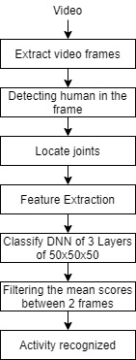

Figure 3-a Framework of Proposed Model

Mean filtering predicts the scores between 2 frames. Then labels are added over the human image if the score is larger than 0.8. In this way the activity is recognized.

3.6 YOLO Framework
The YOLO framework (You Only Look Once) on the other hand, deals with object detection in a different way. It takes the entire image in a single instance and predicts the bounding box coordinates and class probabilities for these boxes. The biggest advantage of using YOLO is its superb speed – it’s incredibly fast and can process 45 frames per second. This is one of the best algorithms for object detection and has shown a comparatively similar performance to the R-CNN algorithms.
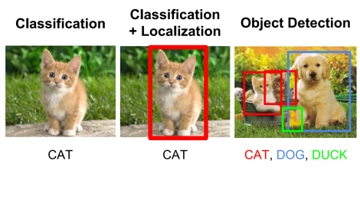
Figure 3-b YOLO Framework

3.6.1 How Does YOLO Work?

Steps followed by YOLO for detecting objects in a given image are as follows:
- YOLO first takes an input image
- The framework then divides the input image into grids (say a 3 X 3 grid).
- Image classification and localization are applied on each grid. YOLO then predicts the bounding boxes and their corresponding class probabilities for objects (if any are found, of course).
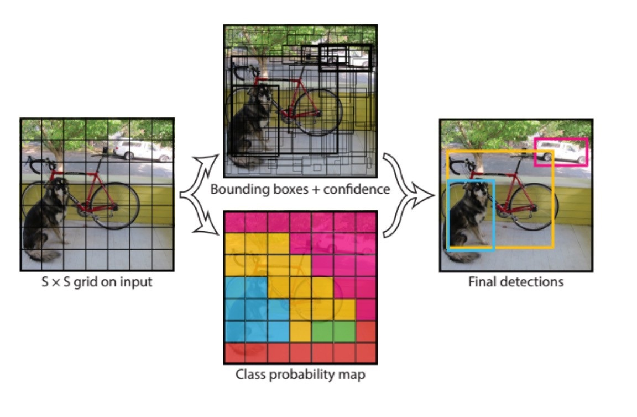
Figure 3-c Formation of Bounding Boxes

We pass the labelled data to the model in order to train it. We have divided the image into a grid of size S X S and then the objects are classified into n number of classes. So, for each grid cell, the label y will be a Q dimensional vector:

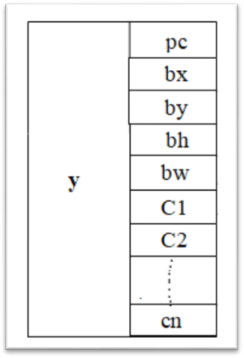
Figure 3-d Grid Classifier

Here,
- p_{c} defines whether an object is present in the grid or not (it is the probability)
- b_{x}, b_{y}, b_{h}, b_{w} specify the bounding box if there is an object
- c₁, c₂, c_{3,…,}c_{n} represent the classes.
If there is no object in this grid, pc will be zero and b_{x}, b_{y}, b_{h}, b_{w}, c₁, c₂,…c_{n} doesn’t matter as there is no object in the grid. YOLO will decide whether there is an object or not by taking the mid-point of the overlapping objects (if present) and these objects will be assigned to the grid which contains the mid-point of these objects. Since there is an object in this grid, p_{c} will be equal to 1. b_{x}, b_{y}, b_{h}, b_{w} will be calculated relative to the particular grid cell we are dealing with. c_{1,}c_{2,}c_{3,….,}c_{n} will be given values according to the class to which the object belongs. So, for each of the 9 grids, we will have an eight dimensional output vector. This output will have a shape of S X S X Q.

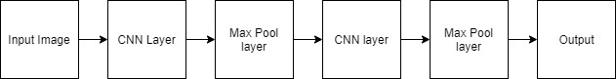
Figure 3-e Layering Process

We ran both forward and backward propagation to train our model. During the testing phase, we pass an image to the model and run forward propagation until we get an output y. Even if an object spans out to more than one grid, it will only be assigned to a single grid in which its mid-point is located.

3.6.2 Encoding of Bounding Boxes
In order to encode the bounding boxes we will need the values of bx, b_{y}, b_{h}, and b_{w} . They will be calculated relative to the above mentioned grid.
p_{c} = 1 since there is an object in this grid and c_{1,}c_{2,}c_{3,….}c_{n} will be assigned values corresponding to the class to which the object belongs. b_{x}, b_{y} are the x and y coordinates of the midpoint of the object with respect to the above mentioned grid. b_{h} is the ratio of the height of the bounding box to the height of the corresponding grid cell.
3.6.3 Intersection Over Non-Max Suppression
In order to decide whether the predicted bounding box is giving us a good outcome or not, Intersection over Union comes into the picture. It calculates the intersection over union of the actual bounding box and the predicted bonding box.

One of the most common problems with object detection algorithms is that rather than detecting an object just once, they might detect it multiple times. The Non-Max Suppression technique cleans up this up so that we get only a single detection per object. This approach works as-

It first looks at the probabilities associated with each detection and takes the largest one.

Now, it looks at all the other boxes in the image. The boxes which have high IoU with the current box are suppressed.

After the boxes have been suppressed, it selects the next box from all the boxes with the highest probability.

Again it will look at the IoU of this box with the remaining boxes and compress the boxes with a high IoU.

Repeat these steps until all the boxes have either been selected or compressed and we get the final bounding boxes.
3.6.4 Anchor Boxes

Each grid can only identify one object. But what if there are multiple objects in a single grid? That can so often be the case in reality. And that leads to the concept of anchor boxes.

Using the Non Max Suppression, the output of only one bounding box is seen. Anchor box are able to output both boxes.

In order to accomplish this by, First, pre-define different shapes called anchor boxes or anchor box shapes. Now, for each grid, there will be many outputs.

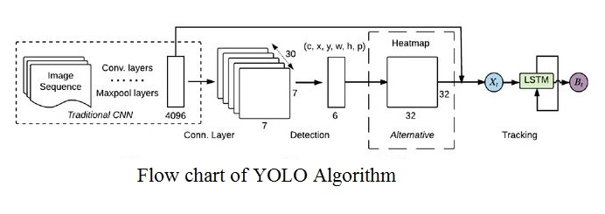
Figure 3-f Flowchart of YOLO Algorithm

3.7 Datasets Used
The JHMDB dataset is composed of 928 videos from movies or the internet which are classified in to 21 action classes: brush hair, catch, clap, climb stairs, golf, jump, kick ball, pick, pour, pull-up, push, run, shoot ball, shoot bow, shoot gun, sit, stand, swing baseball, throw, walk, and wave. Since there are 21 action classes in the dataset, we only need only few actions classes like run, walk, wave which can easily eminent from the pose data. The resolution of each video is 320x240 pixels. Total three splits are performed in the dataset, on the other hand, JHMDB-1 represent to split 1 consisting of the pose data and JHMDB-GT represent JHMDB ground truth for the JHMDB-1 pose data. The evaluation is computed on each slit of which each get 30% of the dataset for the training purposes. The result is computing by taking mean from all the splits.

Chapter 4
Implementation and Result Analysis

The proposed model’s results are demonstrated through following figure 2. Initially when the frames are given as input to the model, the objects are detected through YOLO algorithm using bounding boxes to detect objects. YOLO first takes an input image. The framework then divides the input image into grids. Image classification and localization are applied on each grid. YOLO then predicts the bounding boxes and their corresponding class probabilities for objects (if any are found, of course). Then open pose is used to detect skeleton as shown in the figure 4-a(i). In the next step the coordinates of the body joints of a human are identified, shown in figure 4-a(ii). After this step a heat map is generated, which helps to identify the posture of the human body, shown in figure 4-a(iii), 4-a(iv). Finally Deep Neural Network (DNN) of 50 x 50 x 50 layers is used to classify and label the human activity. Figure 4-a(v) shows the labeling of the activity.

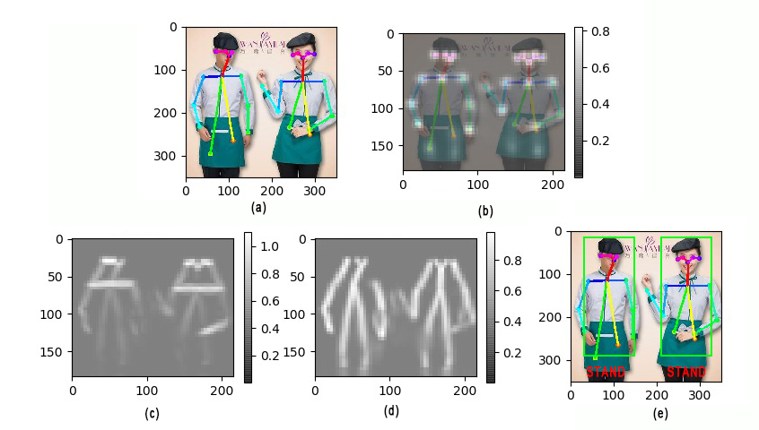

Figure 4-a Implementation-(i) Skeleton detection (ii) Joint detection (iii) Heat map generation (iv) Enhanced heat map generation (v) Labelling of the Human Activity

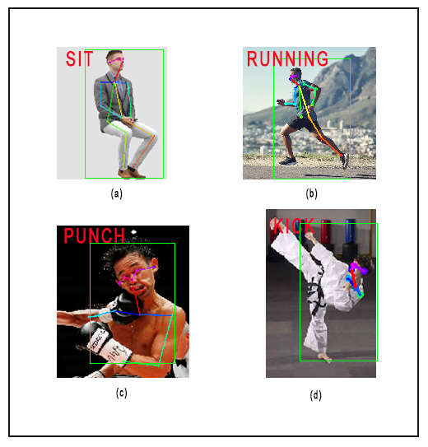

Figure 4-b Other Human Activities

The performance of the proposed approach on different datasets can be represented in table 1.
Data set Name | Accuracy%
JHMDB^{[19]} | 93.8
HMDB52^{[20]} | 95.2
UCF101^{[21]} | 95.2
KTH^{[22]} | 93.9

Table 4-a: Accuracy of Proposed Approach on Different Video Datasets
Chapter 5
Conclusion

In this work we have proposed a model that can recognize various activities done by humans in real time. In our proposed work human recognition is done by using object detection and activity detection with the help of Deep Neural Network (DNN)[23]. We have also compared the performance of our proposed approach on different video datasets like JHMDB, HMDB52, UCF101, and KTH. Our approach on activities recognition works consistantly on different datasets. We have used 9 types of activities like “stand”, “walk”, “run”, “jump”, “sit”, “squat”, “kick”, “punch”, and “wave”. In the future work it should be used with more number of actions in order to provide wide area of application. To improve the performance of the proposed model on a large data set, it can be implemented with a GPU of higher processing power.
References

[1] Wang, Limin, Zhe Wang, Wenbin Du, and Yu Qiao. "Object-scene convolutional neural networks for event recognition in images." In Proceedings of the IEEE conference on computer vision and pattern recognition workshops, pp. 30-35. 2015.
[2] Sandeep Rathor & R.S. Jadon, “Acoustic domain recognition using ensemble based multilevel classfication”, journal of Ambient computing and humanized computing (Springer), vol. 11, issue 9, pp.3617-3627.
[3] Duan, Lixin, et al. "Visual event recognition in videos by learning from web data." IEEE Transactions on Pattern Analysis and Machine Intelligence 34.9 (2011): 1667-1680.
[4] Xiong, Y., Zhu, K., Lin, D., & Tang, X. (2015). Recognize complex events from static images by fusing deep channels. In Proceedings of the IEEE Conference on Computer Vision and Pattern Recognition (pp. 1600-1609).
[5] Wang, L., Shi, J., Song, G., & Shen, I. F. (2007, November). Object detection combining recognition and segmentation. In Asian conference on computer vision (pp. 189-199). Springer, Berlin, Heidelberg.
[6] Jiang, Y. G., Bhattacharya, S., Chang, S. F., & Shah, M. (2013). High-level event recognition in unconstrained videos. International journal of multimedia information retrieval, 2(2), 73-101.
[7] Ren, Z., Pandit, V., Qian, K., Yang, Z., Zhang, Z., & Schuller, B. (2017, December). Deep sequential image features on acoustic scene classification. In Proc. DCASE Workshop, Munich, Germany (pp. 113-117).
[8] Burel, G., Saif, H., Fernandez, M., & Alani, H. (2017). On semantics and deep learning for event detection in crisis situations.
[9] Mun, S., Park, S., Han, D. K., & Ko, H. (2017). Generative adversarial network based acoustic scene training set augmentation and selection using SVM hyper-plane. Proc. DCASE, 93-97.
[10] Redmon, Joseph, and Ali Farhadi. "Yolov3: An incremental improvement." arXiv preprint arXiv:1804.02767 (2018).
[11] J. Deng, W. Dong, R. Socher, L. Li, and and, “ImageNet: A large- scale hierarchical image database,” in IEEE Conference on Computer Vision and Pattern Recognition (CVPR), June 2009, pp. 248–255..
[12] T.-Y. Lin, M. Maire, S. Belongie, J. Hays, P. Perona, D. Ramanan, P. Dolla´r, and C. L. Zitnick, “Microsoft COCO: Common Objects in Context,” in Computer Vision – ECCV 2014, ser. Lecture Notes in Computer Science, D. Fleet, T. Pajdla, B. Schiele, and T. Tuytelaars, Eds. Springer International Publishing, 2014, pp. 740–755.
[13] B. Xiao, H. Wu, and Y. Wei, “Simple Baselines for Human Pose Es- timation and Tracking,” in Computer Vision – ECCV 2018, V. Ferrari, M. Hebert, C. Sminchisescu, and Y. Weiss, Eds. Springer International Publishing, 2018, pp. 472–487.
[14] Mykhaylo Andriluka, Leonid Pishchulin, Peter Gehler, Bernt Schiele; The IEEE Conference on Computer Vision and Pattern Recognition (CVPR), 2014, pp. 3686-3693
[15] Bouguet, Jean-Yves. "Pyramidal implementation of the affine lucas kanade feature tracker description of the algorithm." Intel Corporation 5, no. 1-10 (2001): 4.
[16] Ludl, Dennis, Thomas Gulde, and Cristóbal Curio. "Simple yet efficient real-time pose-based action recognition." In 2019 IEEE Intelligent Transportation Systems Conference (ITSC), pp. 581-588. IEEE, 2019.
[17] Jhuang, H., Gall, J., Zuffi, S., Schmid, C., & Black, M. J. (2013). Towards understanding action recognition. In Proceedings of the IEEE international conference on computer vision (pp. 3192-3199).
[18] Kuehne, H., Jhuang, H., Garrote, E., Poggio, T., & Serre, T. (2011, November). HMDB: a large video database for human motion recognition. In 2011 International Conference on Computer Vision (pp. 2556-2563). IEEE.
[19] Kuehne H., Jhuang H., Stiefelhagen R., Serre T. (2013) HMDB51: A Large Video Database for Human Motion Recognition. In: Nagel W., Kröner D., Resch M. (eds) High Performance Computing in Science and Engineering ‘12. Springer, Berlin, Heidelberg
[20] Soomro, K., Zamir, A. R., & Shah, M. (2012). UCF101: A dataset of 101 human actions classes from videos in the wild. arXiv preprint arXiv:1212.0402.
[21] D. Weinland, E. Boyer, and R. Ronfard. Action recognition from arbitrary views using 3D exemplars. ICCV, 2007.
[22] Zhao, Z., Li, X., Du, X., Chen, Q., Zhao, Y., Su, F., & Hauptmann, A. G. (2018). A unified framework with a benchmark dataset for surveillance activities detection. Neurocomputing, 278, 62-74.

[23] Bashar, A. (2019). SURVEY ON EVOLVING DEEP LEARNING NEURAL NETWORK ARCHITECTURES. Journal of Artificial Intelligence, 1(02), 73-82.

